**KEY Keystone Style Multiple Choice Questions for Of Mice and Men**

**Chapter 1:**

1. What does the word drawn mean as used in the following passage?

“Lennie knelt and looked over the fire at the angry George. And Lennie’s face was drawn with terror” (11).

1. colorful
2. represented in an abstract way
3. tense
4. satisfied
5. Based on the information in this chapter, which conclusion can be made about why George and Lennie are looking for a new job?
6. They want to earn higher pay.
7. They were run out of town by their former employer.
8. Their job their ended, so they had to move on.
9. They left in order to avoid trouble.
10. What effect does the third person point of view have on the chapter?
11. It allows the reader to understand the feelings of George and Lennie.
12. It allows the reader to sympathize with the main characters.
13. It allows the reader to develop dislike towards ranch owners.
14. It allows the reader to understand George’s motives.

**Chapter 2:**

1. This novel was originally published in 1937. Which of these sentences best describes the historical significance in this chapter and throughout the novel?
2. It represents the transient lifestyle of migrant workers.
3. It shows the harmonious relationship between nature and society.
4. It shows the value of traditional family structure.
5. It presents a critique of modern technology and its impact on society.
6. What is the main effect of the dialect used in this chapter?
7. It creates a serious mood.
8. It adds a bit of humor.
9. It exposes the characters’ internal feelings.
10. It creates more realistic characters.
11. Read the sentences from the chapter.

“A girl was standing there looking in. She had full, rouged lips and wide-spaced eyes, heavily made up. Her fingernails were red. Her hair hung in little rolled clusters, like sausages. She wore a cotton house dress and red mules, on the insteps of which were little bouquets of red ostrich feathers. “I’m lookin’ for Curley,” she said. Her voice had a nasal, brittle quality” (31).

*How does the author’s use of imagery in the sentences help to communicate an idea?

1. It provides a vivid description highlighting superficial beauty.
2. It provides an objective description of the author’s opinion of beauty.
3. It provides general information about Curley’s wife and her personality.
4. It provides specific details that help the reader identify conflict between characters.

**Chapter 3:**

Which sentence is a key detail that **best** completes the summary?

1. George punches Lennie in order to make him let go.
2. Carlson hitches up the wagon to take Curley to the doctor.
3. Curley agrees to lie to the boss about what happened to his hand.
4. George assures Lennie he can still tend the rabbits
5. Read the incomplete summary of Chapter Three.

* Slim gives Lennie one of his pups.
* Carlson shoots Candy’s dog.
* Curley picks a fight with Lennie.
* Lennie breaks Curley’s hand.
* _________________________.

1. Which passage from the chapter **best** supports the generalization that life is more meaningful when spent in the company of others?
2. “I seen the guys that go around on the ranches alone. That ain’t no good. They don’t have no fun. After a long time they get mean. They get wantin’ to fight all the time.”
3. “Hardly none of the guys ever travel together. I hardly never seen two guys travel together… Never seem to give a damn about nobody.”
4. “It ain’t so funny, him an’ me goin’ aroun’ together… Got kinda used to each other after a little while.”
5. “When they can me hear I wisht somebody’d shoot me. But they won’t do nothing like that. I won’t have no place to go, an’ I can’t get no more jobs.”
6. Which sentence(s) best represents the major conflict in Chapter Three?
7. “ ‘Course Lennie’s a God damn nuisance most of the time.”
8. “You get right up an’ take this pup back to the nest. He’s gotta sleep with his mother. You want to kill him?”
9. “Ranch with a bunch of guys on it ain’t no place for a girl, specially like her.”
10. “Come on, ya big bastard. Get on your feet. No big son-of-a-bitch is gonna laugh at me.”

**Chapter 4:**

10. Read the following paragraph.

“Crooks sat on his bunk. His shirt was out of his jeans in back. In one hand he held a bottle of liniment, and with the other he rubbed his spine. Now and then he poured a few drops of the liniment into his pink-palmed hand and reached up under his shirt to rub again. He flexed his muscles against his back and shivered” (Steinbeck 67).

Which word is a synonym for liniment?

1. Liquid
2. Ointment
3. Analgesic
4. Grease

10. Ch. 4: Read the sentence from the passage.

“”So maybe you better jus’ scatter along now, ‘cause Curley maybe ain’t gonna like his wife out in the barn with us ‘bindle stiffs’ ” (Steinbeck 78).

*Which feeling is being suggested by the use of the word bindle stiffs?

1. Respect
2. Disgust
3. Compassion
4. Contentment

11. Ch. 4: Based on the Candy and Lennie’s enthusiasm for “rabbits,” which American cultural idea is most emphasized?

1. The desire to live in wide open spaces.
2. The desire to raise and care for a pet.
3. The desire to form a business partnership and succeed.
4. The desire to plan for and achieve one’s goals.

12. Ch. 5: Read the sentences from the passage.

“Curley’s wife laughed at [Lennie]. ‘You’re nuts,’ she said. ‘But you’re a kinda nice fella. Jus’ like a big baby’ ” (Steinbeck 90).

*What does the opinion used in the sentence contribute to the passage?

1. Curley’s wife’s opinion implies that Lennie cries often.
2. Curley’s wife’s opinion clarifies that Lennie is certifiably insane.
3. Curley’s wife’s opinion shows that Lennie is innocent like a child.
4. Curley’s wife’s opinion proves that Lennie is unintelligent.

13. Ch. 5: Which universal theme is **most** reflected in the Curley’s wife’s description of the movies?

1. Everyone wants to be famous.
2. Everyone needs to know someone who is connected in order to get ahead in life.
3. Everyone wants more money than he or she could spend.
4. Everyone needs to feel envied.

14. Ch. 5: Why is a third person point of view most likely used to describe events in the barn?

1. The author hopes the characters will not be able to uncover the truth.
2. The author builds suspense for the reader as the deaths are discovered.
3. The author wishes for the reader to be as surprised as the characters.
4. The author plans to kill off another character.

15. Ch. 6: Which sentence **best** describes the relationship of the setting to the plot in the final chapter?

1. Lennie returns to a place of safety, making his death more tragic.
2. George returns to a former campsite to recall fond memories.
3. Curley invades the peaceful riverbank, bringing his violent tendencies.
4. Slim joins George in the woods, taking over Lennie’s place as George’s friend.

16. Ch. 6: Which sentence from the passage **best** represents Lennie’s internal conflict as he waits by the stream?

1. “You ain’t fit to lick the boots of no rabbit. You’d forget ‘em and let ‘em go hungry” (Steinbeck 102).
2. “Lennie, you can’t remember nothing that happens, but you remember ever’ words I say” (Steinbeck 103).
3. “You ain’t gonna leave me, are ya, George? I know you ain’t” (Steinbeck 103).
4. “Look acrost the river, Lennie an’ I’ll tell you so you can almost see it” (Steinbeck 105).

17. Ch. 6: What does George **most likely** do at the end of the book after he walks off with Slim?

1. George buys the farm in memory of Lennie.
2. George runs off to join the circus.
3. George becomes a solitary ranch hand like the others.
4. George returns to his last job in Weed.

**Keystone Style Constructed Response Questions for Of Mice and Men**

* **Chapter 1**:

Analyze what the interactions between George and Lennie in Chapter One, reveal about their relationship. Use information from the chapter to support your analysis.

* **Chapter 2:**

Using pages 17-19, analyze what the setting reveals about life as a ranch hand. Use information from the chapter to support your analysis.

* **Chapter 3:**

Analyze how Steinbeck’s uses the events in Weed to foreshadow Lennie’s interaction with Curley at the end of the chapter. Use information from the chapter to support your analysis.

* **Chapter 4:**

Analyze what Crooks’ perspective on the American Dream reveals about his personality. Use information from the chapter to support your analysis.

* **Chapter 5**:

Analyze how Steinbeck uses imagery in the following passage to establish mood:

*It was very quiet in the barn, and the quiet of the afternoon was on the ranch. Even the clang of the pitched shoes, even the voices of the men in the game seemed to grow more quiet. The air in the barn was dusky in advance of the outside day. A pigeon flew in through the open hay door and circled and flew out again. Around the last stall came a shepherd bitch, lean and long, with heavy, hanging dugs. Halfway to the packing box where the puppies were she caught the dead scent of Curley’s wife, and the hair rose along her spine. She whimpered and cringed to the packing box, and jumped in among the puppies (Steinbeck 92).*

* **Chapter 6:**

During the imaginary conversation between Lennie and his Aunt Clara, analyze how Steinbeck’s use of dialect and word choice help to establish the relationship between Lennie and his aunt.

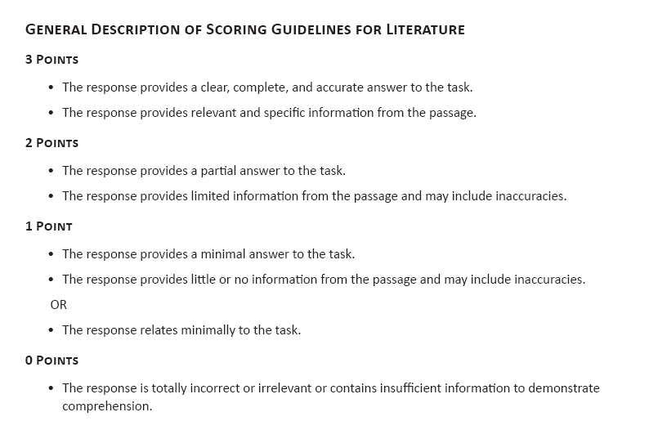

**Key:**

1. C

2. D

3. A

4. A

5. D

6. A

7. C

8. A

9. D